**INNOVATION FOR COVID19 CASES ANALYSIS**

**Problem statement:**

Covid 19 cases analysis, the objective of this project is to analyze and gain insights from COVID-19 cases data, with a focus on understanding the spread, impact, and mitigation strategies related to the pandemic. The analysis will involve examining various aspects of the pandemic, including but not limited to.

#### **Summary Data Columns Description:**

* **country**: designates the Country in which the row's data was observed.
* **continent**: designates the Continent of the observed country.
* **total confirmed**: designates the total number of confirmed cases in the observed country.
* **Total_deaths**: designates the total number of confirmed deaths in the observed country.
* **Total_recovered**: designates the total number of confirmed recoveries in the observed country.
* **active_****cases**: designates the number of active cases in the observed country.
* **Serious_or_critical**: designates the estimated number of cases in serious or critical conditions in the observed country.
* **total_cases_per_1m_population** designates the number of total cases per 1 million population in the observed country.
* **total_deaths_per_1m_population** designates the number of total deaths per 1 million population in the observed country.
* **total tests**: designates the number of total tests done in the observed country.
* **total_tests_per_1m_population** designates the number of total tests done per 1 million population in the observed country.
* **population**: designates the population count in the observed country.

#### **Daily Data Columns Description:**

* **date**: designates the date of observation of the row's data in YYYY-MM-DD format.
* **country**: designates the Country in which the row's data was observed.
* **Cumulative_total_cases** designate the cumulative number of confirmed cases as of the row's date, for the row's country.
* **daily_new_cases**: designates the daily new number of confirmed cases on the row's date, for the row's country.
* **active_cases**: designates the number of active cases (i.e., confirmed cases that still didn't recover nor die) on the row's date, for the row's country.
* **cumulative_total_deaths**: designates the cumulative number of confirmed deaths as of the row's date, for the row's country.
* **daily_new_deaths**: designates the daily new number of confirmed deaths on the row's date, for the row's country.

**TIME SERIES OF CASES:**

base_stats = pd.DataFrame(columns=['Dates','Confirmed','Deaths','Recovered','Active'])  
base_stats['Dates'] = confirmed_df.columns[4:]  
  
base_stats['Confirmed'] = base_stats['Dates'].apply(lambda x: confirmed_df[x].sum())  
base_stats['Deaths'] = base_stats['Dates'].apply(lambda x: deaths_df[x].sum())  
base_stats['Recovered'] = base_stats['Dates'].apply(lambda x: recoveries_df[x].sum())  
base_stats.reset_index(drop=False, inplace=True)  
base_stats['Active'] = base_stats['index'].apply(lambda x: (base_stats['Confirmed'][x]-(base_stats['Deaths'][x]+base_stats['Recovered'][x])))  
base_stats.head()

**SOURCE CODE:**

**Dataset Link:** [**https://www.kaggle.com/datasets/chakradharmattapalli/covid-19-cases.**](https://www.kaggle.com/datasets/chakradharmattapalli/covid-19-cases.)

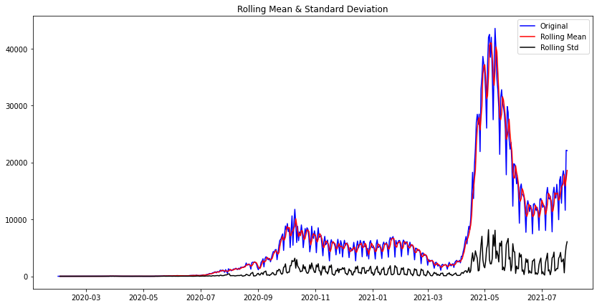

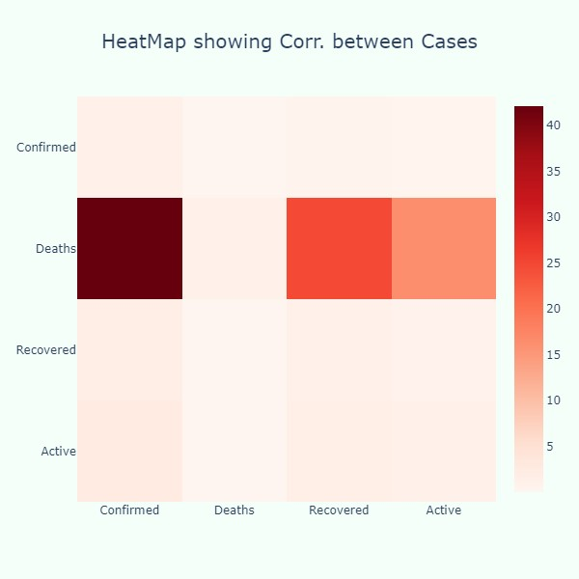

**Overall view of Analysis**

Conclusion

The “COVID-19 Cases Analysis” project aims to provide a valuable resource for individuals, healthcare professionals, and policymakers. By offering real-time data, interactive maps, and customizable filters, this platform will empower users to make informed decisions and better understand the dynamics of the COVID-19 pandemic.